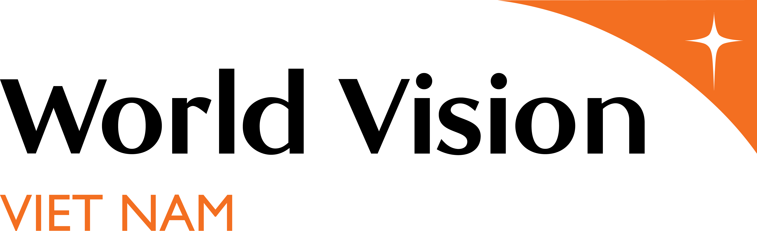
WORLD VISION VIETNAM
POSITION DESCRIPTION

KEY POSITION INFORMATION
Job Title | WVV Special Project Assistant | Hay Grade level |  | 12
Reports To | Project Manager
Department/Group | Field Operations | Location | Ham Thuan Bac, Binh Thuan

WORK CONTEXT / BACKGROUND:

World Vision is a Christian relief and development organization working to create lasting change in the lives of children, families and communities living in poverty. World Vision serves all people regardless of religion, race, ethnicity or gender. As a child-focused organization, WV’s work focuses on children, ensuring they are protected and their basic needs are met. WVV has been funded from 14 support countries in Europe, Asia, the Americas and Australia. Funding of WVV consists of sponsorship program funding (70%) and PNS/grants (30%). WVV employs about 430 staff, of which 99% are Vietnamese nationals.

Currently, World Vision Vietnam is operating in 5 zones: North 1 (Hoa Binh and Dien Bien), North 2 (Yen Bai – Tuyen Quang), North 3 (Thanh Hoa, Hai Phong), Centre (Quang Tri, Quang Nam – Danang) and South (Quang Ngai, Binh Thuan, Ho Chi Minh, DakNong). WVV’s AP usually focuses within one administrative district of a province which populated by ethnic minority people with high rates of poverty. A uniqueness of WVV’s Area Program (AP) is that AP team members are based at district level where the AP is located, which enables them to work closely with government partners and communities on a daily basis. Beside the APs, WVV is also implementing different Special and Grant Projects to meet the specific needs of vulnerable children in both AP and non-AP areas.

Southeast Asia is one of the most at-risk sub-regions globally regarding natural and climate-related hazards. COVID-19 and its secondary effects compound these risks, incl. the economic impact caused by the need for stringent public health measures. Although women are one of the most affected population in disasters, their voices in decision-making results in issues important are not often being prioritised in Disaster preparedness policies. Moreover, considering specific gender, age, and disability needs, evidence indicating violence against children and Gender-based Violence (GBV) tends to increase amongst disaster-affected and marginalised groups in hard-to-achieve and conflict contexts.

From Oct 2021, World Vision will commence a project name "Enhancing inclusive and gender-responsive forecast-based early action (FBEA) for effective disaster preparedness in Vietnam and at regional level" which aims at strengthening awareness, capacity and resilience of local communities and actors, and engaging them in policy dialogue through evidence-based advocacy. This is a project co-implemented by CARE International, Plan International and World Vision International in Vietnam (WVIV) for 18 months (from 1 July, 2021 until December 2022). The project is funded by European Civil Protection and Humanitarian Aid Operations.

PURPOSE OF POSITION:

To assist the Project Manager in designing, implementing and monitoring the FBEA Project in the assigned sites to achieve the goal, outcomes, and outputs stated in the FBEA design document and logical framework.

ROLE DIMENSION / DESCRIPTION | End Results Expected | Time Spent
Design and Planning | - All project activities are implemented and coordinated under the Logframe/Design Document of the FBEA Project, in light of the WVV’s HEA/DRR strategy.  - Coordinate and involve project staff, project partners, consortium partners and consultants to plan, implement, monitor and evaluate project activities according to the project’s plan and to ensure the sustainability of the project;  - Gender & Resilience marker materials, especially on Disaster Risk Reduction documents and data are searched, collected and used for the project objectives; | 20%
Project Activities Implementation, Monitoring and Reporting | - Assistance is provided to the Project Manager in project planning, implementation and review by developing and ensuring quality, realistic plans of action, budgets, and monitoring and evaluation of activities, outputs, and outcomes. This will be done in alignment with WV’s Learning through Evaluation with Accountability and Planning (LEAP) Framework.  - Work with local partners and others to ensure that planned targets of the project are achieved.  - Community project ownership is facilitated by conducting community participation activities to ensure that the resources of the project will create direct benefit to community members, specially towards vulnerable HHs with indigenous people/poor ethnic minority women, elderly, people with disability, lactating and pregnant women, most vulnerable children.  - Project’s progress is kept track and information is updated in liaison and collaboration with other agencies.  - Assistance is provided to the Project Manager in developing project reports, including interim and final narrative progress reports according to Donor standards and WV MnE standards  - Perform other administrative tasks as assigned by Project Manager | 70%
Organizational Learning | - Attend workshops, training and other capacity building activities and learn to be a trainer as required;  - Assistance is provided to the Project Manager in documenting project best practices and project stories, photos. | 10%

No. Direct Report: | 0 | Positions Supervised: | 0
Other Reporting Relationships | None
Financial Authority | None
Annual Total Budget | Around 173,000 USD
Decision Making Authority | Within WVV Policies and Guidelines

Important Functional Relationships:
Contacts | Reason for Contact | Frequency of Contact
Project Manager | Overall guidance and leadership | Daily
Project Bookkeeper | Financial issues | Daily
DRR Manager/Specialist | Technical Support | Weekly
Government Partners | Project Operation including Assessment, Design, Implementation, Monitoring and Evaluation. | Daily
Hamlet Facilitators/Volunteers | Project Operation including Assessment, Design, Implementation, Monitoring and Evaluation. | Daily
Other NGOs, CBOs, FBOs, Businesses. | Partnering, Networking, Relationship Building | Occasionally

Major Challenges:
Challenge |  | Possible Approaches/Solutions
- The requirement of being based at the project sites in the remote areas, living far away from the family. |  | - Housing and Transportation benefits are provided.  - Appropriate staff care
- Work under high pressure with continuous changes and new initiatives to adopt. |  | - Be trained on Change Management Skills, Time Management and Planning Skills.

Knowledge, Skills, Abilities:
Education | - Bachelor degree, preferably in environment, community development, social work or related areas |  | - Essential
Knowledge & Skills | - Conceptual understanding of and commitment to development work, especially Christian, child-focused, community-based development concepts, approaches and processes.  - Basic knowledge and understanding of key aspects of disaster risk management; environmental protection; development work; including child protection, gender, disability, child protection and participation.  - Demonstrated capacity in project management, with conceptual understanding and required competency in DME functions (e.g. Facilitate monitoring processes with partners and community, analyze and interpret monitoring data).  - Strong interpersonal skills and well-developed written and oral communications skills in Vietnamese.  - Ability to think critically and reflect.  - Fair English skill.  - Solid computer skills in Word, Excel, PowerPoint and email. |  | - Essential  - Essential  - Essential  - Essential  - Essential  - Essential  - Essential
Experience | - At least 2 years of work experience in community development.  - Experience in disaster risk reduction/climate change adaptation, early action would be an advanced.  - Experience in program implementation, community mobilization and participatory approach  - Experience in working with local stakeholders/partners. |  | - Essential  - Essential  - Preferred
Work Environment | - Based at district level  - Working in team environment and under minimum supervision
Core Competencies: | Be Safe and Resilient:  I take care of my personal well-being and support others to do the same.
Build Relationships:
I treat others with empathy and respect so that trust grows and we can speak the truth with love.
Learn and Develop:
I create opportunities for myself and others to grow, strengthen competence and improve performance.
Partner and Collaborate:
I engage and influence networks of people beyond my role to make a bigger difference than we could alone.
Deliver Results:
I focus on and help achieve the things that matter most, with clear evidence of my contribution
Be Accountable:
I exercise wise stewardship showing sound judgment and integrity in the decisions and choices I make.
Improve and Innovate:
I seek and discover new and better ways of doing things, solve problems, and turn ideas into action.
Embrace Change:
I approach change and the opportunities it offers with openness and courage and I encourage others to do the same.

Prepared by Hiring Manager: | Date:
Reviewed by People and Culture Director: | Date:
Agreed & Accepted by the Job Holder: | Date:

